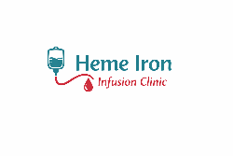
Hematology and Iron Infusion Clinic

15315 - 66 Avenue, Suite 311, Surrey, BC V3S 2A1

Fax: 604-398-8265 I Tel: 604-332-7988

Email: Admin@heme-iron-infusion.ca

Your IV Iron Infusion Visit: What to Bring & What to Expect

What to bring
- Government-issued photo ID
- Health card
- List of current medications and allergies
- Comfortable clothing with easy arm access

What to expect on the day of your infusion
- Check-in and verification of your information
- Review of medical history and consent
- IV insertion and monitored iron infusion
- Short observation period after the infusion
- Discharge home the same day
The total time in the clinic is typically 45–60 minutes, including observation.

After your infusion
- Resume normal activities unless advised otherwise
- Drink fluids
- Mild symptoms may occur for 24–48 hours
- Contact the clinic if you have concerns

Heme Iron Infusion Clinic | Surrey, British Columbia
This document is for informational purposes only and does not replace medical advice.

